SR | USER Requirements | GPT Results | VeriGen Results
 | The system supports multilingual interface. | - The system shall provide users with the ability to select their preferred language for the interface.  2. The system shall be able to display all interface elements in multiple supported languages. | 1. The system shall be able to support multilingual interface.
 | The system designs in manner that operational data is not lost in case of any failure of equipment or communication network. | 3 The system shall be able to store operational data in a manner that prevents data loss in case of equipment failure.  4 The system shall be able to store operational data in a manner that prevents data loss in case of communication network failure. | 2. The system shall be able to designs operational manner that data lost case failure equipment or communication network.
 | The system works even in an offline mode with the critical functionality. | 5 The system shall be able to store operational data in a manner that prevents data loss in case of communication network failure.  6 The system shall be able to synchronize data automatically when network connectivity is restored after offline operation. | 3 The system shall be able to work even in an offline mode with the critical functionality.
 | The system designs to have satisfactory performance even in Police Stations connected on low bandwidth. | 7. The system shall be able to maintain satisfactory performance when accessed from police stations with low bandwidth connections. | 4. The system shall be able to design to have satisfactory performance even in police stations connected on low b 5 Width.
 | The system implements using Service Oriented Architecture (SOA) and have a modular design. | 8 The system shall be implemented using Service Oriented Architecture (SOA).  9 The system shall have a modular design to allow independent deployment and maintenance of modules. | 6. The system shall be able to implement using service oriented architecture soa and have a modular design.
 | The system develops on Open Standards. | 10 The system shall be developed using open standards for interoperability. | 7. The system shall be able to develop on open standards.
 | The system build’s on a common User Access and Authentication Service to ensure Single-Sign on for the end-user. | 11 The system shall use a common User Access and Authentication Service for all user authentication.  12 The system shall provide users with the ability to log in using Single Sign-On (SSO). | 8. The system shall be able to build on a common user access and authentication service to ensure singlesign on for the enduser.
 | The system develops for a centralized deployment and maintenance. | 13 The system shall be designed for centralized deployment.  14 The system shall be designed for centralized maintenance. | 9. The system shall be able to develop for a centralized deployment and maintenance.
 | The system develops to be deployed in a 3-tier datacenter architecture. | 15 The system shall be deployable in a 3-tier datacenter architecture. | 10. The system shall be able to develop to deployed in a 3tier datacenter architecture.
 | The system designs to have a n-tier architecture with the presentation logic separated from the business logic that is again separated from the data-access logic. | 16 The system shall implement an n-tier architecture with presentation logic separated from business logic.  17 The system shall implement an n-tier architecture with business logic separated from data-access logic. | 11. The system shall be able to design to have a ntier architecture with the presentation logic separated from the business logic that again separated from the dataaccess logic.
 | The system extensible to provide access to the interfaces through PDA’s and mobile data terminals | 18 The system shall be extensible to provide access through PDA devices.  19 The system shall be extensible to provide access through mobile data terminals. | 12. The system shall be able to extensible to provide access to the interfaces through pdas and mobile data terminals.
 | The system adopts standardized formats and common metadata elements . | 20 The system shall adopt standardized data formats for all data exchanges.  21 The system shall use common metadata elements for all data entities. | 13. The system shall be able to adopt standardized formats and common metadata elements.
 | The system designs for access through browser-based systems and must impose minimal requirements on the client device. | 22 The system shall provide access through browser-based interfaces.  23 The system shall impose minimal hardware and software requirements on client devices. | 14. The system shall be able to designs minimal access browserbased systems and impose requirements client device.
 | The system supports multiple types of communication services for remote access. | 24 The system shall support multiple types of communication services for remote access. | 15. The system shall be able to support multiple types of communication services for remote access.
 | The system capability to support public access to a subset of data and functionality. | 25 The system shall be able to provide public access to a subset of data as configured.  26 The system shall be able to provide public access to a subset of functionality as configured. | 16. The system shall be able to support public capability access subset data and functionality.
 | The system supports multi-tier authentication where required. | 27 The system shall support multi-tier authentication where required by configuration. | 17. The system shall be able to support multitier authentication where required.
 | The system supports SSL encrypted connections. | 28 The system shall support SSL encrypted connections for all network communications. | 18. The system shall be able to support ssl encrypted connections.
 | The system supports secure virtual private network connections. | 29 The system shall support secure Virtual Private Network (VPN) connections for remote access. | 19. The system shall be able to support secure virtual private network connections.
 | The system uses HTTPS as the communication protocol, i.e., HTTP over an encrypted secure socket layer (SSL). | 30 The system shall use HTTPS (HTTP over SSL) as the default communication protocol. | - The system shall be able to use https as the communication protocol , i.21. E.  22. , http over an encrypted secure socket layer ssl.
 | The system runs on multiple browsers. | 31 The system shall be compatible with multiple web browsers. | 23. The system shall be able to run on multiple browsers.
 | The system supports selective encryption of the stored data. | 32 The system shall support selective encryption of stored data based on data sensitivity. | 24. The system shall be able to support selective encryption of the stored data.
 | The system ensures secure transmission of data over the network and utilize SSL and 2-way digital signatures. | 33 The system shall ensure secure transmission of data over the network using SSL.  34 The system shall utilize 2-way digital signatures for secure data transmission. | 25. The system shall be able to ensure secure transmission of data over the network and utilize ssl and 2way digital signatures.
 | The system ensures high standards of security and access control through prevent cross-site scripting. | 35 The system shall prevent cross-site scripting (XSS) attacks in all user input fields. | 26. The system shall be able to ensure high standards of security and access control through prevent crosssite scripting.
 | The system ensures high standards of security and access control through validate the incoming data / user request. | 36 The system shall validate all incoming data and user requests for correctness and security.  37 The system shall encode all incoming data and user requests before processing. | 27. The system shall be able to ensure high standards of security and access control through validate the incoming data user request.
 | The system ensures high standards of security and access control through prevent SQL Injection. | 38 The system shall prevent SQL Injection attacks in all database interactions. | 29. The system shall be able to ensure high standards of security and access control through prevent sql injection.
 | The system ensures high standards of security and access control through utilize parameterized queries. | 39 The system shall utilize parameterized queries for all database operations. | 30. The system shall be able to ensure high standards of security and access control through utilize parameterized queries.
 | The system ensures high standards of security and access control through sanitize the user-inputs. | 40 The system shall sanitize all user inputs before processing or storage. | 31. The system shall be able to ensure high standards of security and access control through sanitize the userinputs.
 | The system ensures high standards of security and access control through validate the data both at the client and server. | 41 The system shall validate data both at the client-side and server-side. | - The system shall be able to ensure high standards of security and access control through encode the incoming data user request.  - The system shall be able to ensure high standards of security and access control through validate the data both at the client and server.
 | The system ensures high standards of security and access control through do not allow hard delete and perform only soft tagging the row for deletion. | 42 The system shall not allow hard deletion of records from the database.  43 The system shall perform only soft tagging of rows for deletion. | 33. The system shall be able to ensure high standards of security and access control through not allow hard delete and perform only soft tagging the row for deletion.
 | The system ensures high scalability and performance through use of cache for storing frequent data. | 44 The system shall use caching to store frequently accessed data for improved scalability and performance. | 34. The system shall be able to ensure high scalability and performance through use of cache for storing frequent data.
 | The system ensures high scalability and performance through use of AJAX based technology to improve user experience. | 45 The system shall use AJAX-based technology to improve user experience and responsiveness. | 35. The system shall be able to ensure high scalability and performance through use of ajax based technology to improve user experience.
 | The system ensures high scalability and performance through aggressive page loading to be considered based on the screen and estimate usage pattern. | 46 The system shall implement aggressive page loading strategies based on screen and estimated usage patterns. | 36. The system shall be able to ensure high scalability and performance through aggressive page loading to considered based on the screen and estimate usage pattern.
 | The system ensures high standards of security and access control through leverage Asynchronous HTTP socket capabilities of web server for scalability and performance. | 47 The system shall leverage asynchronous HTTP socket capabilities of the web server for scalability and performance. | 37. The system shall be able to ensure high standards of security and access control through leverage asynchronous http socket capabilities of web server for scalability and performance.
 | The system ensures high scalability and performance through host all the static content (documents, images) on the web server. | 48 The system shall host all static content, including documents and images, on the web server. | 38. The system shall be able to ensure high scalability and performance through host all the static content documents , images on the web server.
 | The system ensures high scalability and performance through the search results should be fetched from the database in batches of 10 or 20 maximum as configured within the application. | 49 The system shall fetch search results from the database in configurable batches of 10 or 20 records. | 39. The system shall be able to ensure high scalability and performance through the search results fetched from the database in batches of 10 or 20 maximum as configured within the application.
 | The system ensures high scalability and performance through display of records on the screen in batches/paged manner. | 50 The system shall display records on the screen in a paged manner. | 40. The system shall be able to ensure high scalability and performance through display of records on the screen in batchespaged manner.
 | The system ensures high scalability and performance through the search should fetch only the fields that need to be displayed to the user. | 51 The system shall fetch only the fields required for display in search results. | 41. The system shall be able to ensure high scalability and performance through the search fetch only the fields that need to displayed to the user.
 | The system ensures high scalability and performance through only when the user clicks on a particular record to view its further details should a query be fired to fetch the additional details for this particular record only. | 52 If a user clicks on a particular record to view its details, then the system shall query and fetch additional details only for that record. | 42. The system shall be able to ensure high scalability and performance through only when the user clicks on a particular record to view its further details a query fired to fetch the additional details for this particular record only.
 | The system ensures high scalability and performance through a hierarchical cache should be configured and used for caching of results of most frequently used searches. | 53 The system shall configure and use a hierarchical cache for results of the most frequently used searches. | 43. The system shall be able to ensure high scalability and performance through a hierarchical cache configured and used for caching of results of most frequently used searches.
 | The system ensures high scalability and performance through database Indexes should be applied on the key columns used for searching. | 54 The system shall apply database indexes on key columns used for searching. | 44. The system shall be able to ensure high scalability and performance through database indexes applied on the key columns used for searching.
 |  | 55. The system shall provide users with feedback when their selected language is applied.
 |  | 56. If an unsupported language is selected, then the system shall display an appropriate error message.
 |  | 57. If network connectivity is lost during an operation, then the system shall notify the user and switch to offline mode if critical functionality is available.
 |  | 58. If data synchronization fails after network restoration, then the system shall log the error and notify the user.
 |  | 59. The system shall provide notifications to users upon successful data synchronization after offline operation.
 |  | 60. The system shall log all authentication attempts for audit purposes.
 |  | 61. If a user authentication attempt fails, then the system shall display an appropriate error message.
 |  | 62. The system shall restrict access to public data and functionality according to configured access control policies.
 |  | 63. If a user attempts to access restricted data or functionality, then the system shall deny access and display an appropriate error message.
 |  | 64. The system shall provide users with feedback when a record is soft-deleted.
 |  | 65. The system shall allow administrators to restore soft-deleted records.
 |  | 66. The system shall validate the format and content of all incoming data against predefined schemas.
 |  | 67. If incoming data fails validation, then the system shall reject the data and display an appropriate error message.
 |  | 68. The system shall encode all outgoing data to prevent injection attacks.
 |  | 69 The system shall provide users with feedback when search results are loaded or updated.
 |  | 70. The system shall log all security-related events, including failed login attempts, detected attacks, and data validation errors.

Class Diagram (GPT)
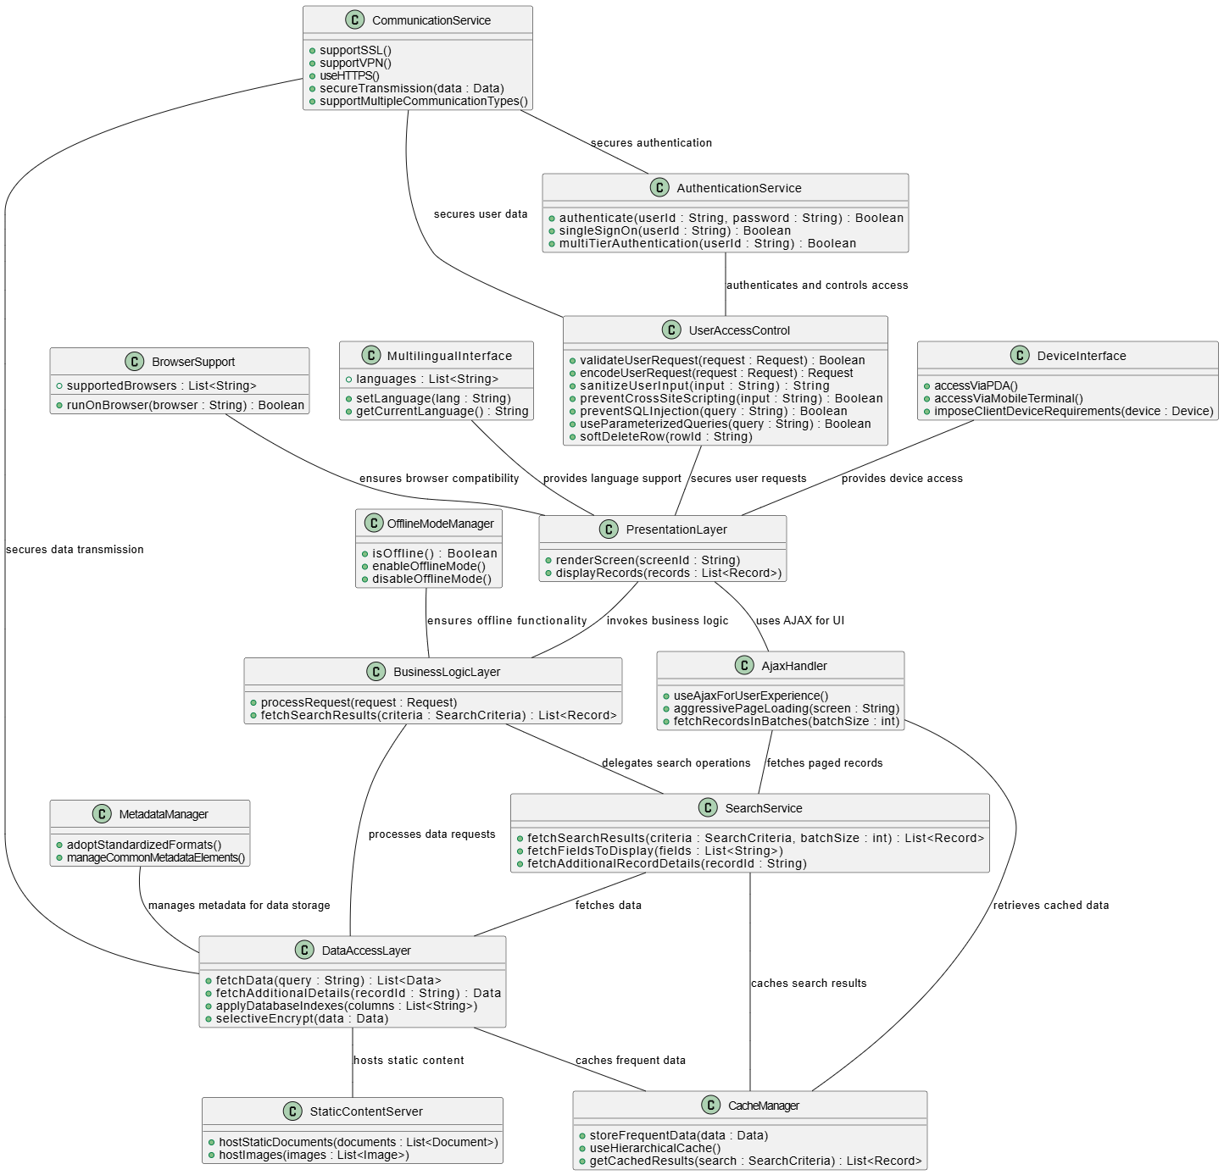

Class Diagram (VeriGen)
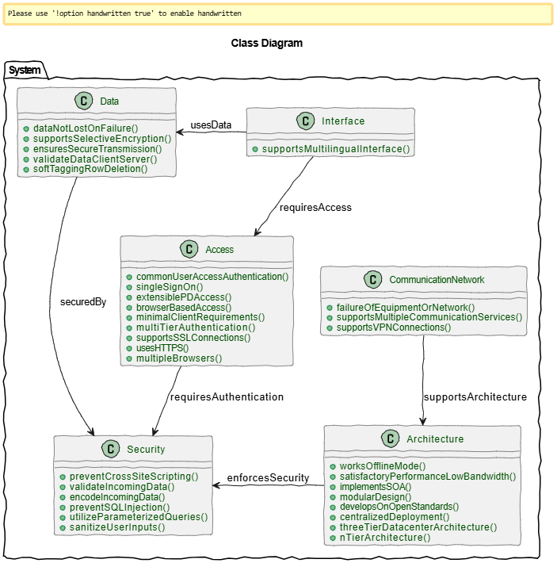

Sequence Diagram VeriGen
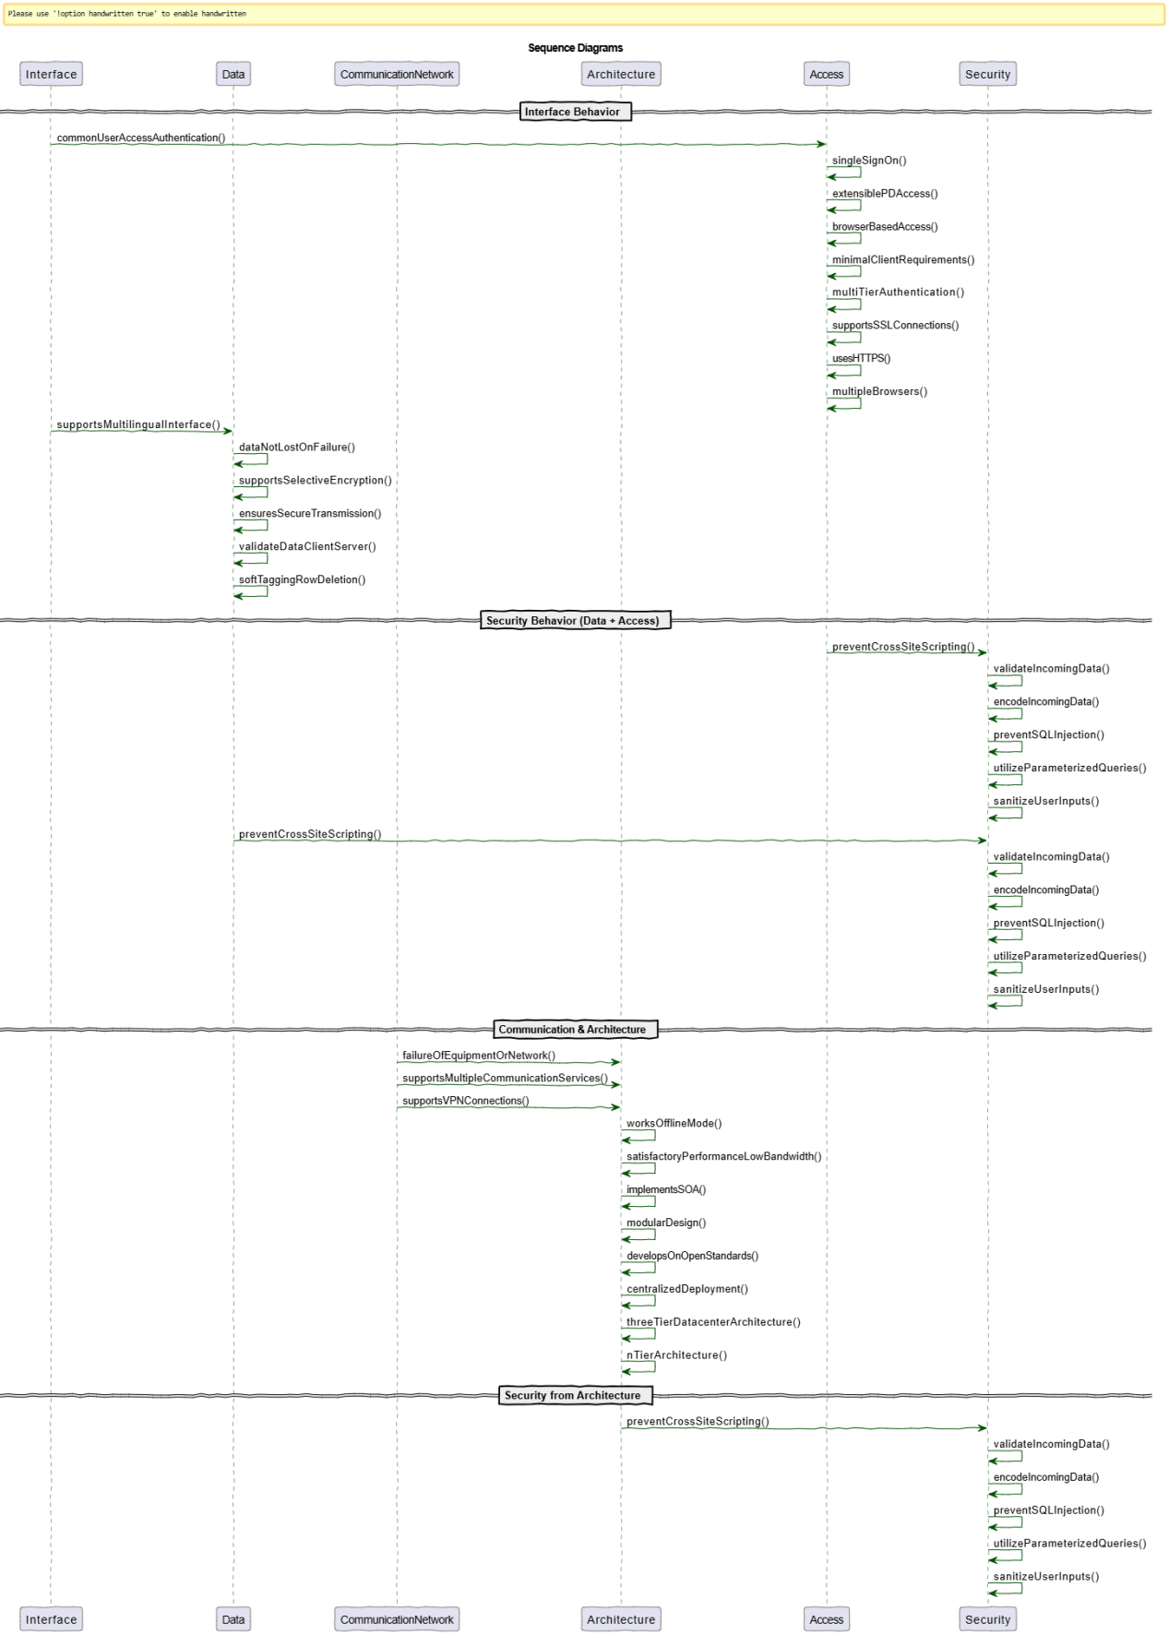

Sequence Diagram (GPT)
